Ohio Art Education Association (OAEA) Mail-In Membership Form
Membership Year - Oct. 1, 2018 - Sept. 30, 2019
- Contact Data
(Check one) _____ New Membership _____Renewal Membership (#_______)
First name |  | Last name
Home address
City | State | Zip | Home county
Preferred email
Home/ cell phone |  | Work phone
School district, institution or organization |  | School building or work site
Work address
City | State | Zip | Work county

2. Membership Divisions and Types: check one
Division: if applicable
⃞ Elementary ($45) | ⃞ Emeritus ($25) | ⃞ HIgher Ed. ($45)  Graduate students welcome | ⃞ Middle/ Jr. High ($45)
⃞ Museum ($45) | ⃞ Pre-service ($25)  Pre-credentialed, full-time college student | ⃞ Secondary ($45) | ⃞ Supervision/ Policy/ Admin. ($45)
Other membership types: if applicable
⃞ Affiliate* ($100)  Group membership for visual arts organizations, arts councils, art centers and non-profits | ⃞ Art Education Professional ($45)  Not in above Divisions | ⃞ Associate ($45)  Friend of OAEA, non-art educator | ⃞ Family ($25)  Name related OAEA member  ___________________ | ⃞ Lifetime* ($200)  One time dues after 30 years active membership
*More detailed benefits and privileges at www.oaea.org/membership

3. Region: circle one  (refer to map to find your county and region):  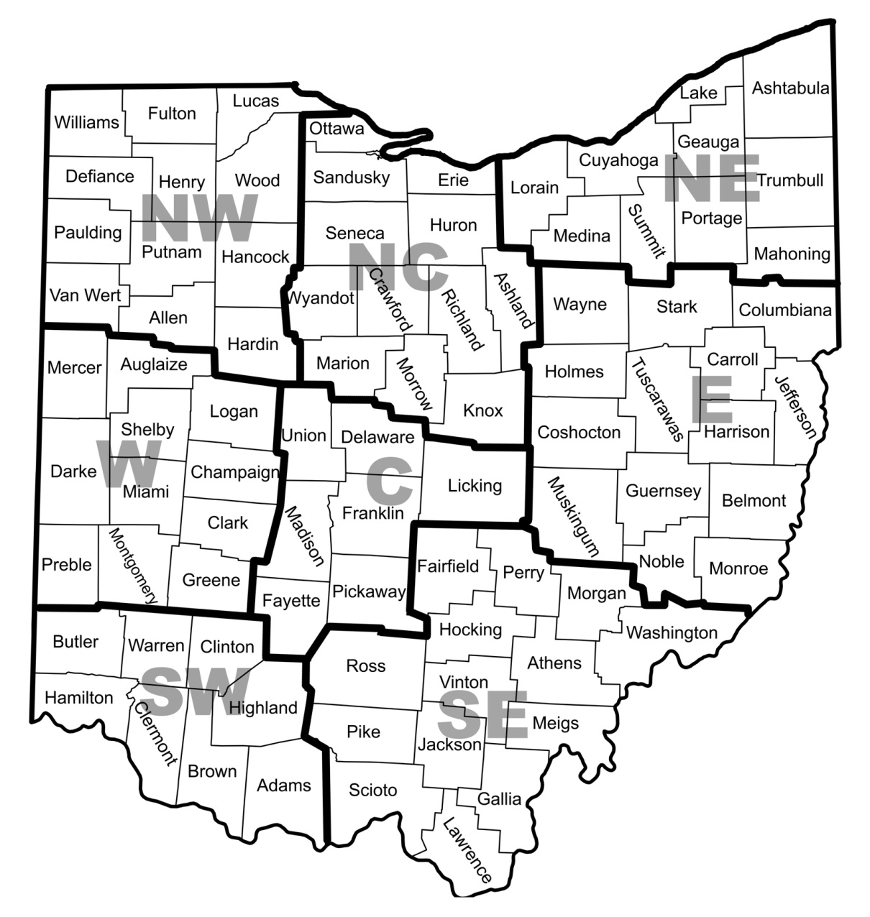  C E NC  NE NW SE  SW W | 4. Payment  Membership Division or Type (from area 2 above) _________________ $  Donation to Ohio Art Education Foundation +$  Total =$  Check payable to OAEA
5. Send this completed form and check payable to OAEA to:
Gayle Mulder, Membership Chair,
2025 High Ridge Road Lima, OH 45805
OR APPLY ONLINE at www.oaea.org. Questions? - contact: membership@ohioarted.com

