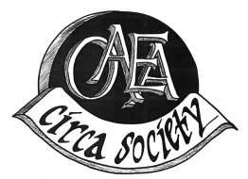2019 Circa Society Application
The Circa Society was established in 1992 to recognize and thank members who support and contribute to making OAEA one of the top art educators’ associations in the nation!
If you have been a continuous member since the 2003-04 school year or before, you are eligible to be inducted in the OAEA Circa Society in 2019. Even if you missed a year, but have at least 15 yrs. membership you qualify for the entry level award. We then recognize your dedication every five years after with a certificate & small gift at the conference awards ceremony.
Though we have records of most past recipients it is helpful if you believe you are eligible for an award this year that you also send in an application. It’s easy to become a part of the Circa Society; to apply fill out this form and send it as an email attachment or mail to the address below. If you have any questions contact Gayle Mulder at membership@ohioarted.com.
First Name Middle Last
Any other name used: married, maiden, nickname, or initials
Address
City State Zip
Home Phone ( ) Cell Phone ( )
Email:

Membership number (# found on your Artline address label or on your OAEA website profile page)
Region Any other region you were a member & years
First year as a member First year teaching
Were you a student member?
Undergraduate university & year of graduation
Forms received by September 1 will be confirmed and inducted at the 2019 Professional Development Conference in Columbus. Forms received after September 1 will be inducted the following year. You must be a current member at the time of application and at conference. If you are unable to attend conference your award will be mailed to you after the conference.
I have been an OAEA member for:
__________________ Years

Please mail or email this form to:
Gayle Mulder, OAEA Membership Chair
2025 High Ridge Road
Lima, OH 45805

