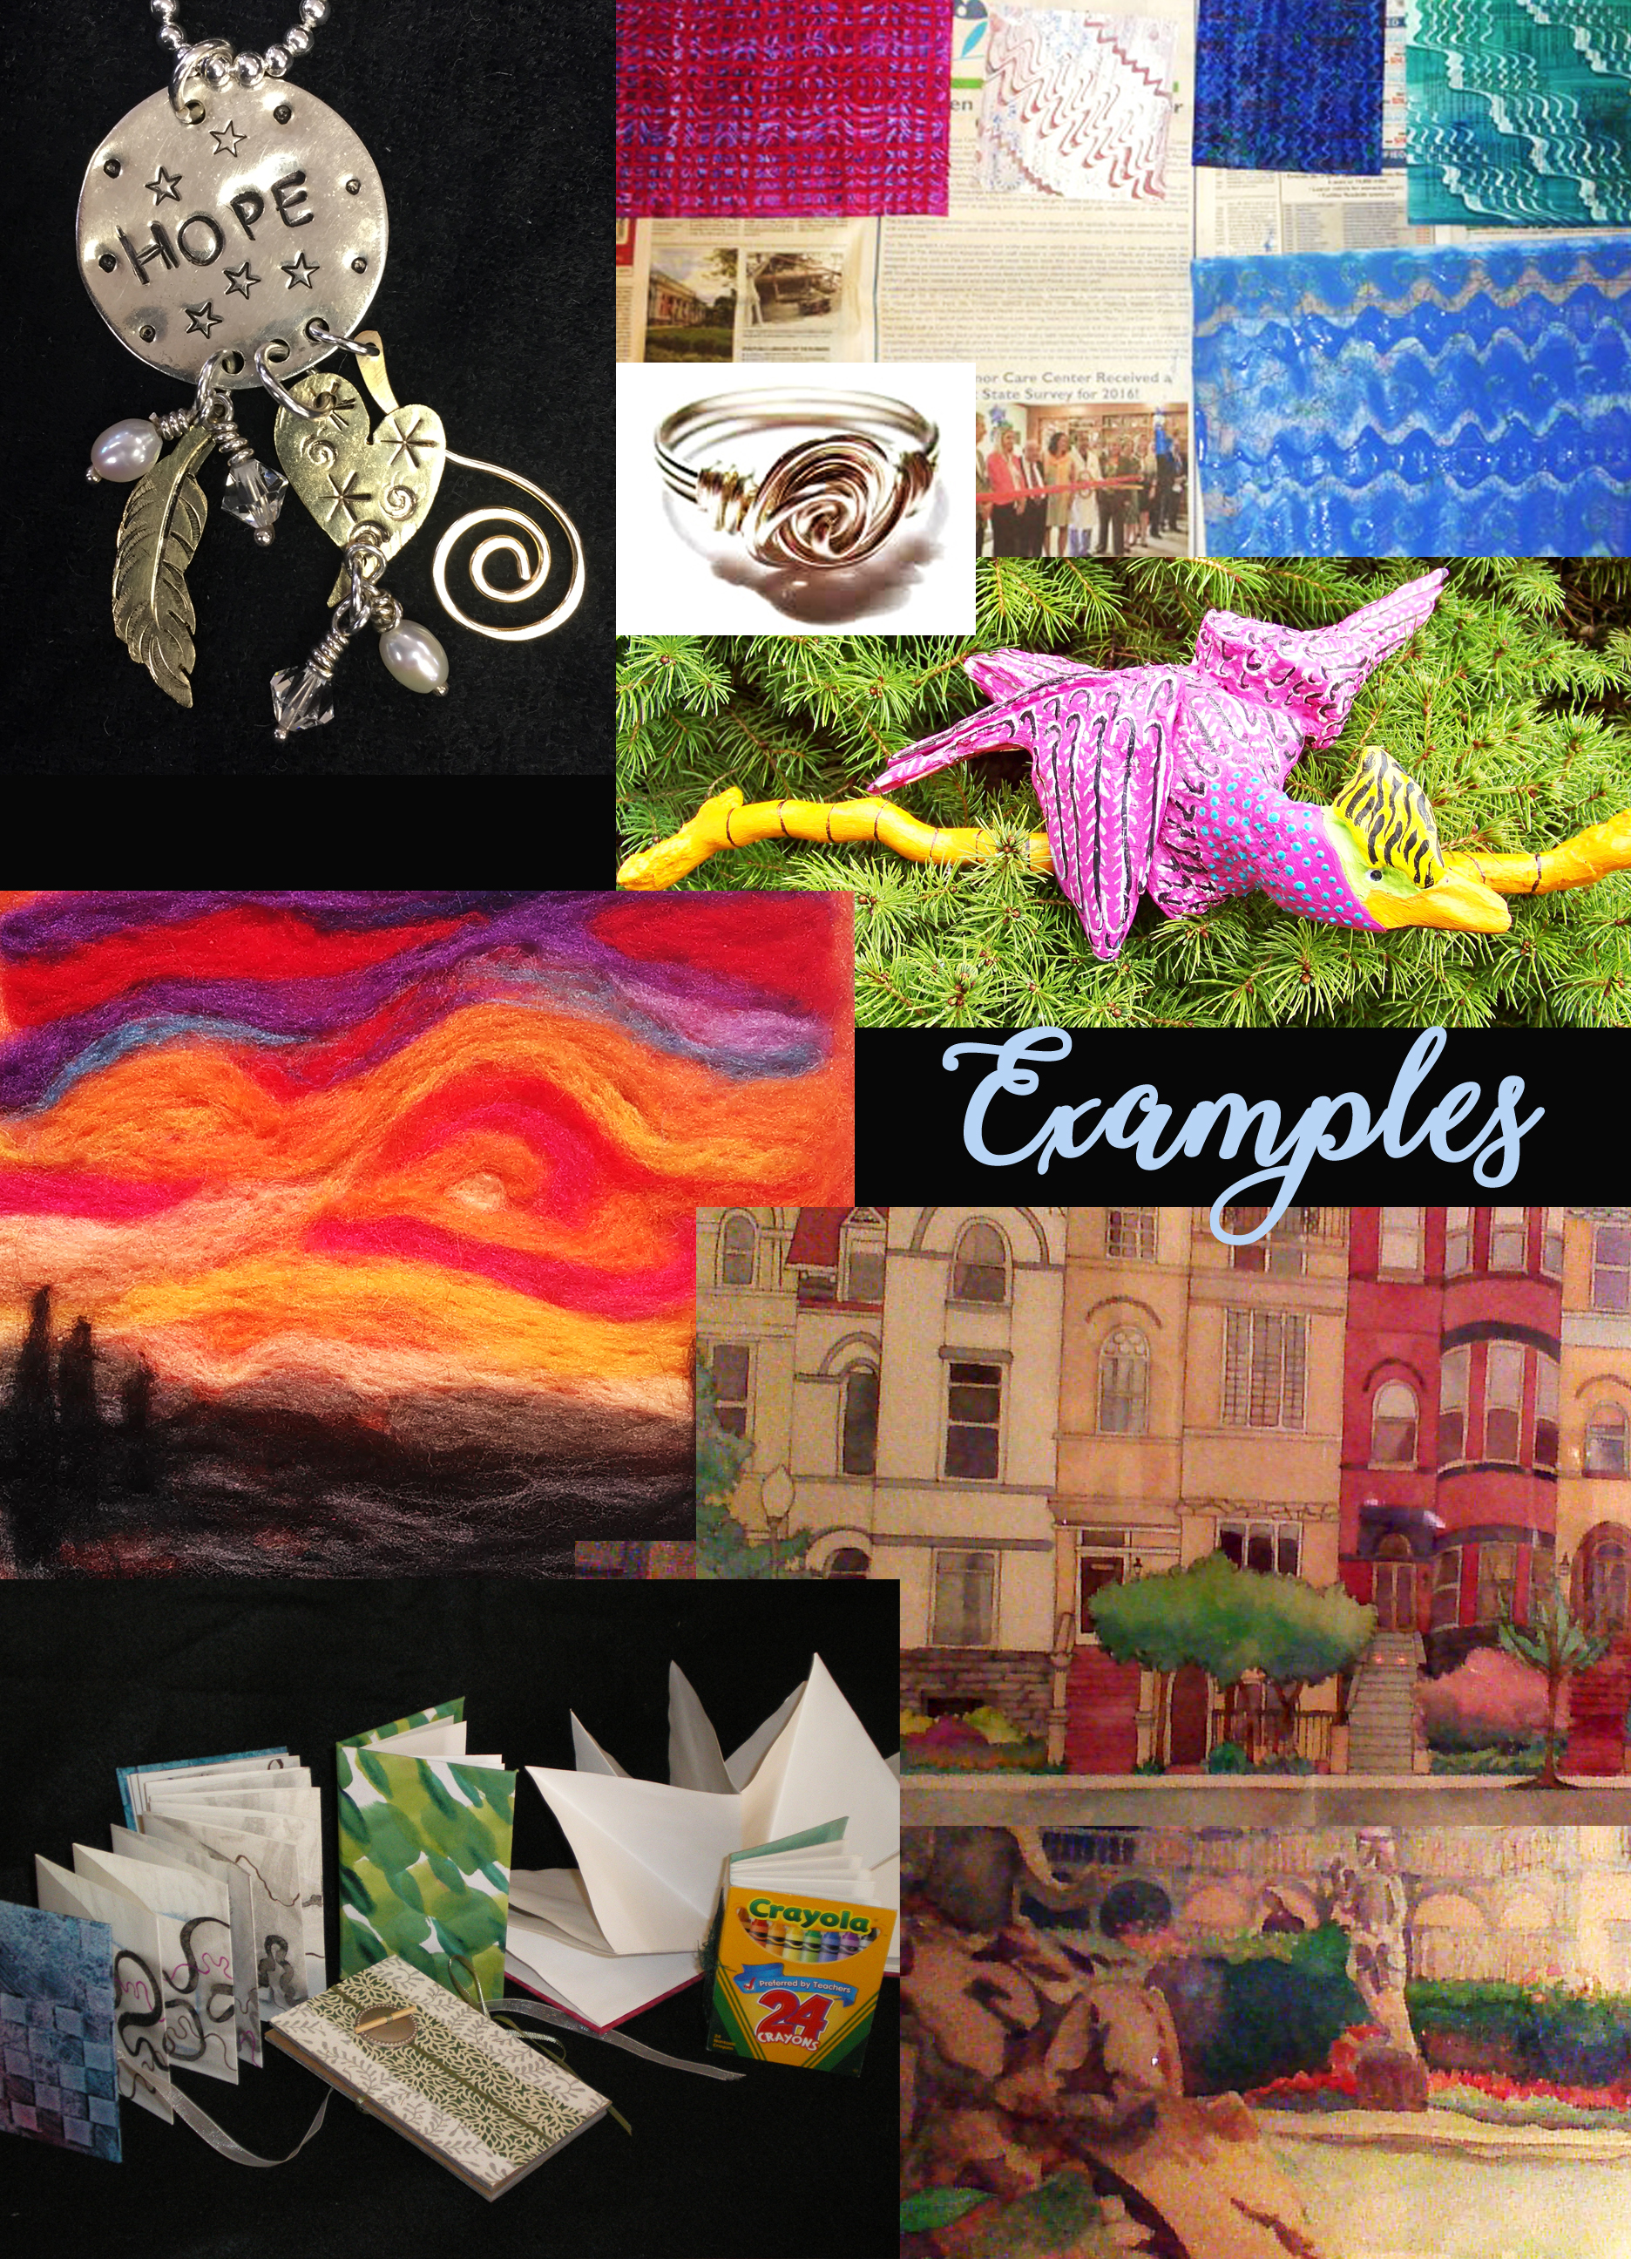OAEA Summer symposium • 2017
Kent state university

Earn 2 PDUs

Tuesday, june 27
Schedule
Participants can check into their dorm rooms
Evening party at Juliann Dorff’s home
Detailed information about rooms, parking, etc. will be emailed to you
along with your schedule approximately 3 days prior to the symposium.

Wednesday, June 28
Schedule
8:30 – 10:00 a.m. Check into dorm rooms
8:30 – 10:00 a.m. Registration & Continental Breakfast
Center for the Visual Arts (CVA) Lobby
10:00 – 11:30 a.m. First Workshop Sessions -CVA
11:30 – 1:00 p.m. Lunch on your own
KSU Student Union is very close
1:00 – 2:30 p.m. Second Workshop Session – CVA
2:45 – 4:15 p.m. Third Workshop Session – CVA
4:30 – 7:00 p.m. Visit the Fashion Museum
Rockwell Hall
5:30 – 7:30 p.m. Dinner on your own
7:30 – 10:00 p.m. CVA will be open to continue
creating and sharing.

CHOICES OF WORKSHOPS OR MASTER CLASSES

Master Class “Color to Dye For”
Dena Gershon, KSU Entire Day
Color, it’s all around us; it affects our moods and lifts our spirits. Come spend a day in the KSU Textile Department’s dye lab exploring color and make your mark using shibori stitch and clamp resist techniques. In addition, Dena will share contemporary approaches to dye work with color that yields one of a kind, luscious color and pattern infused silk. Participants will spend the first part of the day learning techniques and exploring possibilities, then use what they learned to create two beautiful finished silk scarves. There will also be the option of creating one of a kind silk fabric that can be incorporated in Dena’s Thursday master class. Extra Lab Fee $45.00

Master Class “Enamel Explorations: Sifting Designs”
Rachel Smith, KSU Entire Day
Participants will have the opportunity to explore beginning enamel techniques and apply them in the creation of a shallow dish for jewelry or trinkets. Samples created to explore techniques may also be converted into small jewelry pieces if desired. This master class will focus on sifting techniques on flat and slightly curved surfaces. This is a great chance to play with color, design, and the variety of effects sifted enames can create while also creating functional and wearable works of art. Open to all levels of experience.
Additional metal and enamels can be purchased through the jewelry metal enameling storeroom with a check written to KSU. Extra Lab Fee $35.00

Hands-on Wksp “Make an Impression with Ceramics”
Barrie Archer, OAEA Fellow 90 minutes
Using reasonably priced materials, create stamps for texturing ceramics (or any-thing else). Bring X-acto knife or scissors, pencil and paper.

Hands-on Wksp “Wool Felted Mini Landscapes and Such”
Sherrie Dennis, OAEA Fellow 90 minutes
Participants will create mini 5” x 5” landscapes made of wool roving. Learn easy techniques that can be used in the classroom. You will receive 2 felting needles to keep.

Hands-on Wksp “Get Addicted to Alcohol Inks”
Alice Bordenkircher Tavani, OAEA Fellow 90 minutes
This is a fun workshop to try alcohol inks if you have not tried them before. Participants will become familiar with the medium working on transparencies first and then try them on ceramic tiles and thrift store pottery. Alice will have a few pieces for you to use but feel free to bring a variety of white pottery from the store like coffee cups, bowls, small planters, candle holders and more. Bring apron and brushes.

Hands-on Wksp “Tiny Treasures”
Laura Tawil, OAEA Fellow 90 minutes
Explore the world of miniature art making with Laura using watercolor pencils.

Hands-on Wksp “Simple Wire Jewelry Projects”
Diane Thorpe, OAEA Fellow 90 minutes
Manipulating wire to make either rings or earrings. Have you always wanted to create a simple ring or two? Or maybe a pair of earrings: You’ll learn some basic wire tips and tricks using simple copper or nickel silver (or painted copper) wire with pliers and a few other simple tools. Diane will supply the tools and wire, and even some buttons to create a fun button ring, but if you have some special buttons or beads you’d like to include in a ring, feel free to bring them along.

Thursday, June 29
Schedule
8:30 – 10:00 a.m. Continental Breakfast
Center for the Visual Arts (CVA) Lobby
Participants turn in their room keys for group checkout by noon
10:00 – 11:30 a.m. First Workshop Sessions -CVA
11:30 – 1:00 p.m. Lunch on your own
KSU Student Union is very close
1:00 – 2:30 p.m. Second Workshop Session – CVA
2:45 – 4:15 p.m. Third Workshop Session – CVA
4:30 Travel safely home

CHOICES OF WORKSHOPS OR MASTER CLASSES

Master Class “Art to Wear: Exploring Texture, Transparency & Drape”
Dena Gershon, KSU Entire Day
Create a unique work of wearable art using one of the earliest known textile techniques --- felting. Laminated felt (also known as Nuno felt) is a variation of wet felting in which wool’s natural tendency to shrink and felt is paired with fine open weave fabric, allowing for limitless textural and design possibilities --- all without a stitch. Dena will provide an assortment of luscious hand dyed silks, merino wool and mohair locks with which you will create a one-of-a-kind, fully reversible piece of Art to wear that drapes beautifully. Open to all levels of experience. Extra Lab Fee $45.00

Master Class “Enamel Explorations: Painted Panels”
Rachel Smith, KSU Entire Day
Liquid enamels allow for painterly expression to occur on hand, inflexible metal in an exciting way. In this master class, each participant will have the chance to explore painting on metal with porcelain liquid enamel. For this mast class, we will fire up our large scale kiln from Ferro, the porcelain enamel company, and work together to create unique panels that each participant can be proud of. Extra Lab Fee $35.00

Hands-on Wksp “Paste Paper”
Lynda Berman, OAEA Fellow 90 minutes
Slather colored paste, scrape or skid unlikely objects and marvel at the LARGE luscious patterned papers you will create in minutes. Take home 5 large sheets. In some ways, this process is similar to gell printing but produces larger, wetter sgraffitto patterns and without the expensive gelli plates. Participants may bring 3 to 5 unexpected mark-making objects that can be subjected to water-based paint (plastic Legos, woolen spools, etc. – try to bring something no one else will).

Hands-on Wksp “Amusing Alebrijes!... Discover Oaxacan Folk Art
Georgann Blair, OAEA Fellow 90 minutes
Learn the story about this folk art from Oaxacan, Mexico. Create your interpretation using Lake Erie driftwood and acrylic paint. Originally, inspirations came from myths, religion and folklore. These sculptures are normally carved from indigenous wood but this modified lesson centers on using found driftwood that will be hot-glued to form an original figure that will be painted. The authentic Oaxacan creatures are colorful, whimsical and magical to see. Vibrant colors and patterns are the norm. Embellishments, photos and handouts provided. Bring a hairdryer.

Hands-on Wksp “Make an Impression!”
Edie Davidson, OAEA Fellow 90 minutes
Learn the basic stamping techniques for creating metal jewelry. Learn how to write names, dates or words on copper, brass, or nickel silver. Participants will be able to select from a variety of metal sizes and shapes, as well as, a variety of stamps in different fonts and designs to create personalized pendants or earrings. Participant will also learn how to correctly use jump rings, form metal in a dapping block, and to attach beads to their work. Bring ballpeen or claw hammer, if possible, along with ear plugs and protective glasses. Please mark any of your tools clearly with your name.

Hands-on Wksp “Handmade Books”
Judy Kahle, OAEA Fellow 90 minutes
Learn to make handmade books to use in your classroom or studio. You’ll learn simple ways to create a variety of soft and hard cover books including a soft cover maze book, a hard cover accordion book and a soft cover pamphlet. You will go home with your samples, a bibliography, a glossary and ideas for classroom use.

Hands-on Wksp “Glorious Sophisticated Grid Designs”
Kurt Reichert, OAEA Fellow 90 minutes
This no-fail design project will replace your adult coloring books and can be useds successfully with your students for extremely sophisticated projects. Using simple tools participants will create a grid of 9 different designs that work together in a cohesive manner. It is a great vehicle for teaching new media with students. Kurt has used it with 6th graders to adults and has never had a bad result. When sitting in your studio trying to decide what subject matter for your next work, you’ll use the grid and be up and running before you go into artist block. Bring your favorite colored pencils.

OAEA Summer Symposium logo designed by erin kraly

